CN LAB 6

21K-3153

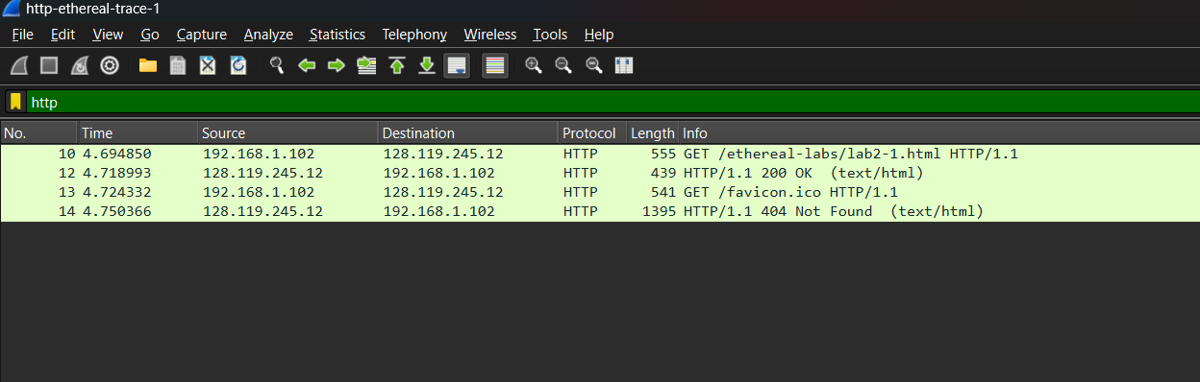

Q1) Running HTTP 1.1



Q2) english, en-us

Q3) Source and Dest IP:

Q4) status code: 200 OK



Last Modified

Q5) 

Q6) 73 bytes

CONDITIONAL HTTP GET

Q1) No if-modified-since

Q2) Yes the server explicitly returned contents, as shown

Q4) Returned status code is 304, not modified



The contents of the file are not returned.

RETRIEVING LONG DOCUMENTS

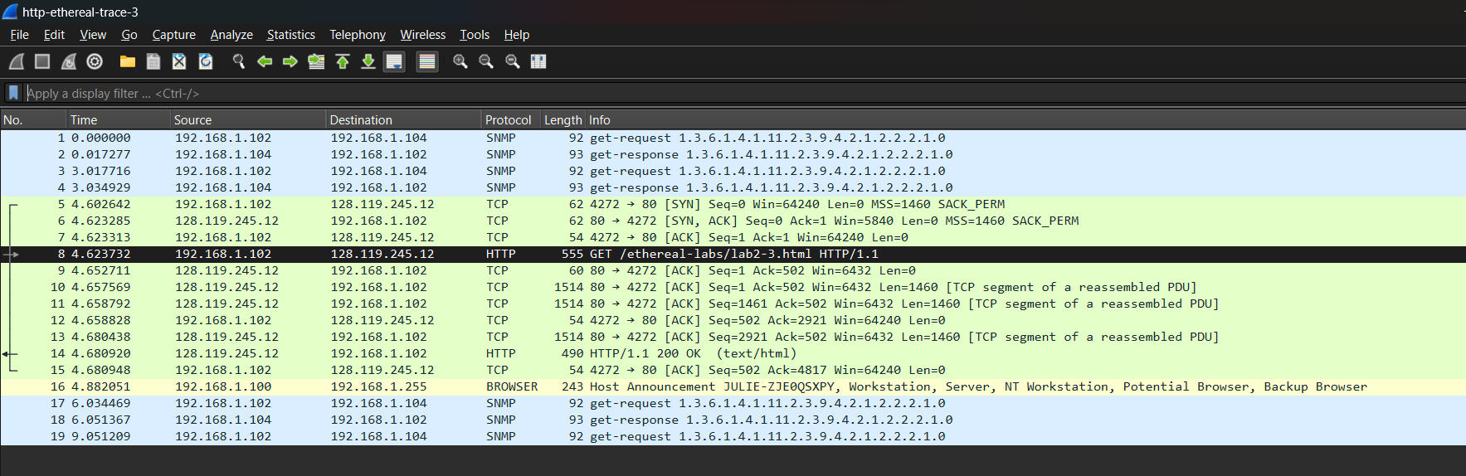

Q1) How many HTTP GET request messages did your browser send? Which packet number in the trace contains the GET message for the Bill or Rights?

1 GET request. Packet 21

Q2) 26

Q3) Status 200 OK

Q4) 

4 reassembled TCP segments

HTML DOCUMENTS WITH EMBEDDED OBJECTS:

1. How many HTTP GET request messages did your browser send?

3 GET requests were sent

2. Can you tell whether your browser downloaded the two images serially, or whether they were downloaded from the two web sites in parallel? Explain.

Done in parallel as 2 GET requests were sent first, then 2 responses were received.

HTTP Authentication:

1. What is the server’s response (status code and phrase) in response to the initial HTTP GET message

from your browser?



Authorization Required

2. When your browser’s sends the HTTP GET message for the second time, what new field is included

in the HTTP GET message?

The authorization is sent

NETWORK TRAFFIC DNS ANALYSIS

1. TCP or UDP

UDP

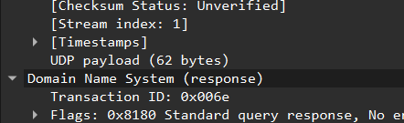

1. Dest and Source Port

Query:

Response:

1. What IP address is the query sent to?

4) Examine the DNS query message. What “Type” of DNS query is it? Does the query message contain

any “answers”?

No Answers. Type A

5) How many answers in DNS response

2 answers

